Symptom-Based Disease Classification Using Supervised and Unsupervised Machine Learning Algorithms

Jose Guiller R. Dela Cruz
College of Computing and Information Technology
National University Philippines
jgdcruz06@gmail.com

Jeriana Yllen P. Maranguis
College of Computing and Information Technology
National University Philippines
jerianamaranguis08@gmail.com

Vanna Victoria E. Hernandez
College of Computing and Information Technology
National University Philippines
vannavictoria04@gmail.com

Abstract—This study explores the use of machine learning to classify disease-related data based on symptoms. The project uses a dataset containing 4,962 records, 132 symptom features, and a disease label called prognosis. Three machine learning algorithms were implemented: K-Means Clustering, Decision Tree, and Bernoulli Naive Bayes. K-Means was selected as the main algorithm because the project focuses on grouping similar symptom patterns into clusters. The reported held-out accuracy of K-Means was 97.5%, while Decision Tree using Gini impurity and Entropy, and Bernoulli Naive Bayes, each reported 100% accuracy. These results show that all three approaches performed well on the available dataset. However, the perfect scores require further verification, and the different data-splitting procedures limit direct comparison. The project demonstrates how machine learning can support the organization of disease-related information, but the system is intended for educational purposes and cannot replace professional medical assessment.
Keywords—Disease classification, machine learning, K-Means clustering, Decision Tree, Naive Bayes
I. INTRODUCTION

A. Background of the Study
Medical data contains a wealth of information about diseases, including symptoms and other characteristics that can help distinguish one condition from another. However, recognizing meaningful patterns within this information can be challenging, particularly when dealing with numerous symptoms and a large number of possible diseases. Different diseases may also share similar symptoms, making it difficult to determine which broader disease classification a particular set of symptoms may correspond to. Healthcare datasets are also complex and can be challenging to analyze due to their size and the variety of information they contain [6]. Traditional analysis of disease-related information may require considerable time and expertise to examine the relationships between symptoms and disease categories. As the amount of medical information increases, there is a need for a more systematic approach that can analyze symptom patterns and organize diseases into meaningful classifications.
Machine learning is a part of artificial intelligence that allows computers to identify patterns in data and use those patterns to perform tasks. In healthcare research, machine learning has been explored for analyzing medical information, identifying relationships between symptoms, and supporting disease classification [1]. Medical data can contain many symptoms and disease labels, making it difficult to examine every possible relationship manually.
Different diseases may share similar symptoms. Because of this, identifying possible disease categories from symptom information can be challenging. Machine learning offers different approaches to this problem. Some algorithms learn from records that already have known labels, while others group records according to similarities in their features.
K-Means is a clustering algorithm that groups data points according to their similarities. It works by assigning records to clusters based on their distance from cluster centers [2]. Decision Tree and Naive Bayes, on the other hand, are supervised learning algorithms that use labeled training data to predict a class [3], [4].
This study may help address the problems mentioned by exploring these three approaches to identify disease and its classification using a dataset containing symptoms and corresponding disease labels. K-Means serves as the main algorithm because the project focuses on clustering symptom patterns. Decision Tree and Bernoulli Naive Bayes are included as comparison algorithms to examine their performance on the same type of disease-related data. By applying machine learning, the proposed system will analyze symptom patterns and classify them into broader disease categories, such as infectious, non-infectious, genetic, and other classifications. The study aims to demonstrate how machine learning can recognize relationships.
B. Research Objectives
The main objective of this study is to explore how machine learning can organize symptom-related records and identify disease labels using clustering and classification techniques.
The specific objectives are:
1. To examine a dataset containing symptoms and their corresponding disease labels.
2. To implement K-Means clustering as the main algorithm for grouping similar symptom records.
3. To implement Decision Tree and Bernoulli Naive Bayes as comparison algorithms.
4. To evaluate the reported performance of the three approaches using the available test results.
5. To develop a simple system that accepts symptom inputs and displays possible disease matches.
6. To identify the limitations of using machine learning for disease-related information and explain why the system cannot replace professional medical assessment.

C. Significance of the Study
This project demonstrates how machine learning can be applied to a dataset containing symptom information. It provides students with practical experience in data preparation, clustering, classification, and model evaluation.
The project may also help readers understand the difference between grouping records based on similarities and predicting labels using previously labeled examples. These approaches can be useful when exploring large datasets containing many features.
The system is an educational demonstration. Its results are not intended to confirm medical conditions, recommend treatment, or replace consultation with qualified healthcare professionals.

D. Scope and Limitations
The study focuses on analyzing a structured dataset containing symptoms and disease labels. The K-Means implementation also accepts symptom names or numbered symptoms and displays up to three closest disease matches.
The dataset contains 4,962 records and 133 columns before the removal of the unnecessary Unnamed: 133 column. The remaining columns consist of 132 symptom features and one prognosis target column. The dataset contains 41 distinct disease labels.
The project is limited to the available dataset and the reported results from the implemented models. It does not use patient examinations, laboratory tests, medical histories collected from actual patients, or clinical validation. The system's predictions and similarity distances cannot establish whether a person has a particular disease.
The study also focuses on the disease labels present in the dataset. Although the original problem statement discusses broader categories such as infectious and non-infectious diseases, the reported model outputs primarily identify specific disease labels. The study does not claim that the system has independently validated all broader disease categories.

II. METHODOLOGY
This section outlines the systematic framework used to process the symptom-based medical data, train the selected models, and evaluate their classification performance. The overall pipeline consists of data collection and preprocessing, model architecture, training procedures, and performance evaluation metrics.
A. Data Collection and Preprocessing
The study utilizes a structured healthcare dataset designed for symptom-based disease prediction.
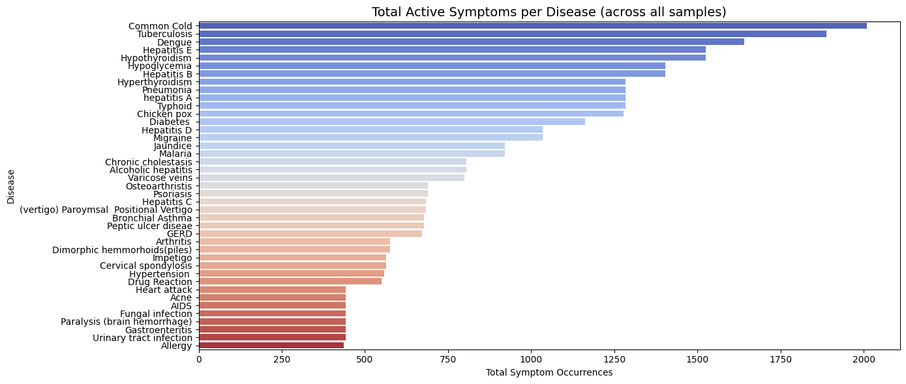
Fig. 1. Aggregate count of active symptom occurrences per disease classification across all dataset samples.
Dataset Overview: The dataset comprises high-dimensional binary features representing distinct symptom occurrences mapped against specific target disease categories.

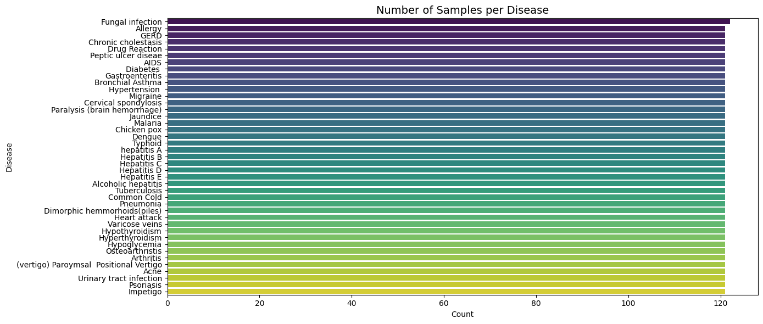
Fig. 2. Class distribution displaying the number of recorded samples across all target disease categories.
Data Preparation: The dataset (mergedData.csv) is natively structured using binary indicator vectors, where a value of $1$ denotes the presence of a symptom and $0$ indicates its absence. Preprocessing involved data cleaning steps such as dropping the redundant Unnamed: 133 column, inspecting dataset dimensions, handling missing entries, and mapping target disease classifications for model training.
Data Splitting: The preprocessed dataset is partitioned into 80% training and 20% testing subsets to ensure unbiased model generalization and prevent overfitting during evaluation.

B. Machine Learning Models

To explore both pattern recognition and predictive classification, three distinct machine learning algorithms are implemented:

- Decision Tree Classifier
This classifier generates a tree structure where internal nodes represent symptom checks and leaf nodes denote predicted disease classifications, providing high model interpretability.
- Bernoulli Naive Bayes
A probabilistic classifier grounded on Bayes’ Theorem, specifically optimized for binary/boolean features [7]. It computes the posterior probability of each disease class given the presence or absence of specific binary symptom indicators, assuming feature independence.
- K-Means Clustering
Applied to group unlabelled symptom profiles into distinct clusters based on feature similarity and Euclidean distance metrics. It also explores natural groupings within the symptom space to evaluate how unguided clustering aligns with known disease labels.

C. Model Training Procedure

- Supervised Training: The Decision Tree and Bernoulli Naive Bayes models are trained using the designated training partition, adjusting structural parameters such as maximum tree depth to optimize predictive convergence.

- Unsupervised Training: K-Means clustering is initialized with predefined cluster centroids corresponding to target classes.

D. Performance Evaluation Metrics

To quantify and compare the efficiency of the classification models, standard multi-class evaluation metrics are computed using the testing dataset:

1. Accuracy: Measures the overall proportion of correctly predicted disease instances out of total evaluations.
2. Precision: Evaluates the ratio of true positive predictions to total predicted positives for each disease category, minimizing false alarms.
3. Recall (Sensitivity): Quantifies the model's ability to correctly identify actual positive instances of a given disease, ensuring minimal missed diagnoses.
4. F1-Score: Computes the harmonic mean of precision and recall, providing a balanced performance metric across classes.
5. Macro-Averaging: Computes metrics independently for each disease class and takes the unweighted average, treating rare and frequent diseases equally to evaluate generalization across all categories.
6. Weighted-Averaging: Computes metrics for each class weighted by its true instance frequency (support), reflecting overall dataset performance where more prevalent diseases exert a higher proportional influence.

III. RESULTS AND DISCUSSION

- Exploratory Data Analysis
Fig. 3. Feature prevalence analysis was performed to
identify the primary clinical indicators dominant within the patient population. As illustrated in Fig. 3, general clinical features such as fatigue, vomiting, and high fever represent the highest overall occurrences across all records, each exceeding 1,000 instances. Identifying these high-frequency baseline symptoms provides context for differentiating non-specific systemic indicators from highly specific localized symptoms during classification.
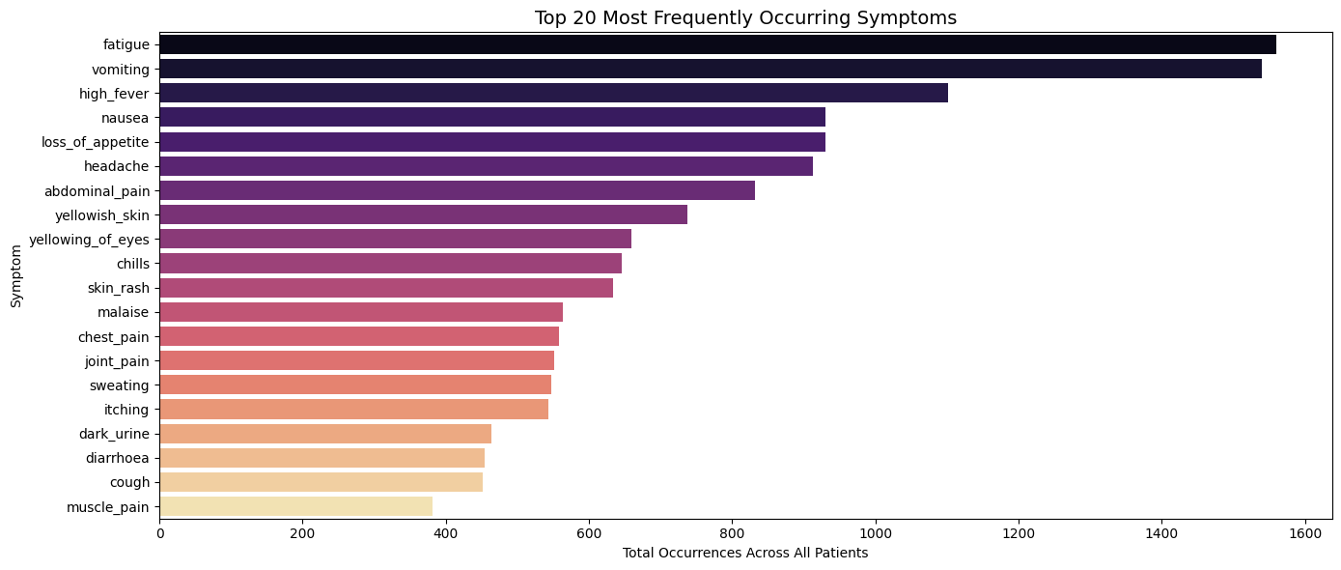
Fig. 3. Frequency distribution of the top 20 most prevalent symptoms recorded across all patient instances.
Fig. 4. To determine diagnostic specificity, a
co-occurrence heatmap was constructed mapping the top 20 symptoms against all individual disease categories. As shown in Fig. 4, distinct color intensities highlight localized symptom profiles corresponding to specific medical conditions. For instance, condition clusters such as Hepatitis variants display dense co-occurrence across liver-related indicators like yellowish skin and yellowing of eyes, demonstrating clear feature separation across distinct diagnostic targets.

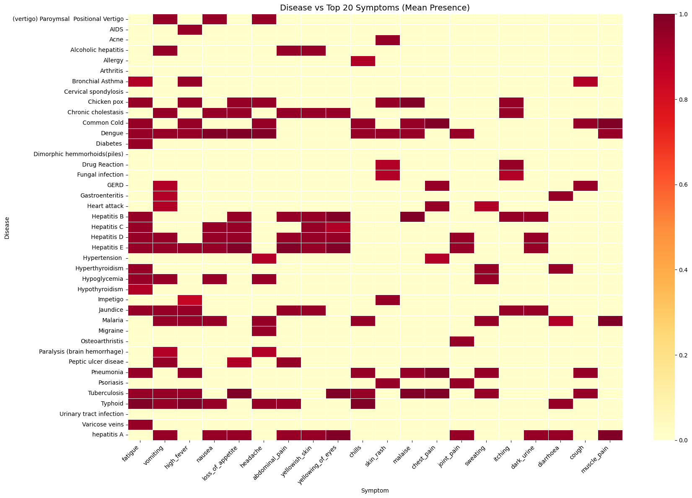
Fig. 4. Heatmap showing the mean presence of the top 20 primary symptoms mapped across each target disease.

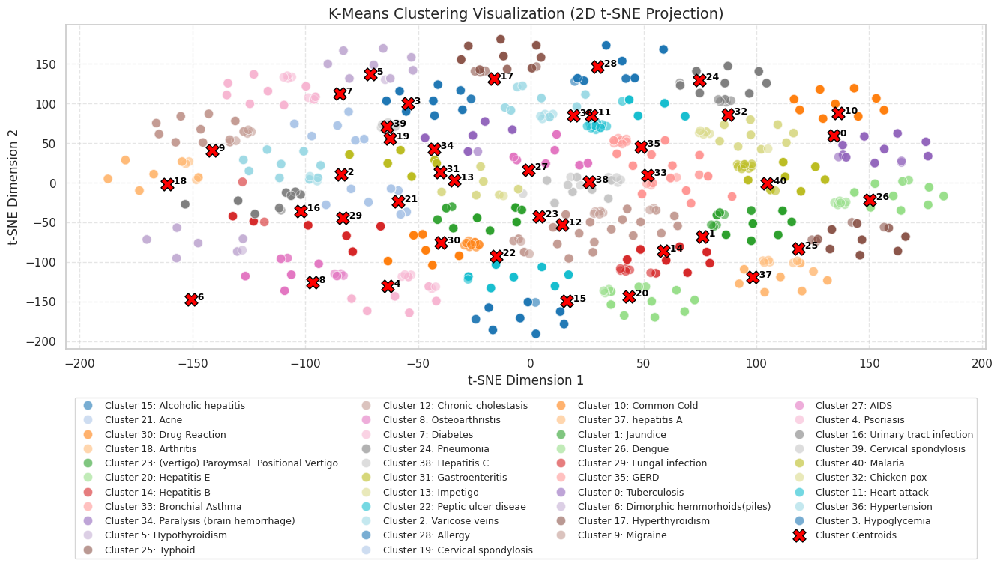
B. K-Means Results
Fig. 5. K-Means Clustering Visualization (2D t-SNE Projection)
Held-out dataset accuracy: 97.5%.
This value was calculated after the clusters were mapped to their majority disease labels. The result indicates that the mapped clusters matched the known disease labels for a high proportion of the evaluated records in the program's held-out test set.
The interactive portion of the program also accepted symptom numbers or names and displayed possible disease matches. In the supplied example, the entered symptoms were cough, headache, throat irritation, phlegm, and runny nose. The closest matches displayed were:
Rank | Disease match | Relative distance
1 | Common Cold | 0.20
2 | Tuberculosis | 9.47
3 | Pneumonia | 9.47
The program also displayed broad categories represented among the closest matches, including immune/allergic and infectious causes, acute or variable courses, and respiratory, urinary, or other body systems.
These categories were descriptive information associated with the displayed matches. The output did not establish the actual cause, duration, affected body system, or contagiousness of a person's symptoms. The relative distances are also not probabilities or confidence scores.
The example demonstrates the system's ability to accept symptom inputs and return ranked matches based on its implementation. It does not demonstrate that the displayed disease is medically correct for a real person.

C. Decision Tree Results
Both Decision Tree configurations reported 100.0% accuracy on 993 test records.
Metric | Gini | Entropy
Accuracy | 100.0% | 100.0%
Macro-average precision | 1.00 | 1.00
Macro-average recall | 1.00 | 1.00
Macro-average F1-score | 1.00 | 1.00
Weighted-average precision | 1.00 | 1.00
Weighted-average recall | 1.00 | 1.00
Weighted-average F1-score | 1.00 | 1.00
Test records | 993 | 993
The program output showed precision, recall, and F1-scores of 1.00 for every displayed class. The confusion matrix was also displayed as a diagonal matrix, with the visible entries showing correct classifications and zero off-diagonal values.
The Gini and Entropy configurations produced the same reported predictions and metrics in the supplied output. Therefore, no performance difference between the two splitting criteria was observed in these runs.

D. Bernoulli Naive Bayes Results
Bernoulli Naive Bayes also reported 100.00% accuracy on 993 test records.
Metric | Reported result
Accuracy | 100.00%
Macro-average precision | 1.00
Macro-average recall | 1.00
Macro-average F1-score | 1.00
Weighted-average precision | 1.00
Weighted-average recall | 1.00
Weighted-average F1-score | 1.00
Test records | 993
The classification report showed precision, recall, and F1-scores of 1.00 for every displayed class. These results indicate that all test records were classified correctly according to the program's evaluation.
The output reflects the performance on the provided test split. It does not independently confirm that the model would achieve the same results on new datasets or real patient data.

E. Comparison of the Algorithms
Table I summarizes the accuracy values reported by the three algorithm implementations.
TABLE I. REPORTED MODEL PERFORMANCE
Algorithm | Accuracy | Test records shown
K-Means Clustering | 97.5% | 993
Decision Tree — Gini | 100.0% | 993
Decision Tree — Entropy | 100.0% | 993
Bernoulli Naive Bayes | 100.00% | 993
Decision Tree and Bernoulli Naive Bayes achieved the highest reported accuracy values. K-Means achieved 97.5%, which was lower than the two supervised approaches in the supplied results.
However, the comparison should be interpreted carefully because the algorithms used different splitting procedures and the supplied logs do not confirm that the same test records were used for all models. The table therefore reports the actual outputs without claiming that the results form a perfectly controlled experiment.
F. Why K-Means Was Selected as the Main Algorithm
K-Means was selected because the project focuses on grouping symptom records according to similarities in their features. This makes it suitable for demonstrating clustering as a way to explore patterns in disease-related data [2].
The project uses K-Means to group records and then maps those groups to disease labels. This allows the system to connect the clusters with known disease names and display possible matches for user-entered symptoms.
Decision Tree and Naive Bayes serve a different purpose. They learn from records with known disease labels and directly predict a label for a new record [3], [4]. Although these models had higher reported accuracy in the supplied outputs, K-Means remains the main algorithm because it demonstrates the clustering method that the project was designed to explore.
This is a choice based on the project's objective, not proof that K-Means is more accurate or more appropriate for clinical diagnosis.

I. Practical Value of the System
The system demonstrates a way to organize symptom-related records and return possible disease matches from a structured dataset. The interactive input feature makes the model easier to demonstrate because users can enter symptom names or numbers and view the closest matches.
This can be useful for educational purposes, data exploration, and demonstrating machine learning concepts. The project also shows how different algorithms can be applied to the same general problem using different approaches.
However, the system does not consider all the information required for a real medical assessment. The displayed results must not be treated as a confirmed diagnosis. The project should be described as an educational disease-classification tool rather than a clinically validated diagnostic system.

IV. CONCLUSION AND RECOMMENDATIONS

A. Conclusion
With how abundant medical data could emerge, troubles and challenges are a questionable seniority. Granted a characteristic of numerous symptoms, mapping out data becomes a grievous task. Without the aid of technology, finding the linkage between a scaling range of symptoms to a disease is a dreadful act. Through this study, the usage of machine learning practices and concepts were used to organize and classify disease-related records. Bridging the gap between multiple symptoms to a candidate representation of diseases. Having said, the project used a dataset containing 4,963 records, 132 symptom features, and 41 distinct disease labels.

Furthermore, three algorithms were implemented: K-Means Clustering, Decision Tree, and Bernoulli Naïve Bayes. Primarily, K-Means was chosen to be the main algorithm with due reasons for clustering similar symptom records. Reaching a held-out accuracy of 97.5% after disease label mapping. On the other hand, the Decision Tree models utilizing Gini impurity and Entropy reported 100.0% accuracy, while Bernoulli Naïve Bayes also reported the same percentage.

The results portray how clustering and supervised classification can be applied to a dataset containing symptoms and disease labels. Although the supervised models retained a higher fraction of accuracy over K-Means, K-means remained as the prime algorithm because it matched the project’s objective through record grouping in accordance with feature similarity. In conclusion, the findings should remain interpreted within the limits of the dataset and evaluation procedures. As bright as the perfect scores reported by Decision Tree and Naïve Bayes are precedence by further verification, highlighting the differences in data splitting. Moreover, the system is intended for educational use and does not provide medically confirmed diagnostics.

B. Recommendations
The following improvements are recommended for future work:
1. Use a consistent evaluation procedure. Apply the same training and testing records to all three algorithms to make the performance comparison fairer.
2. Check the dataset carefully. Examine duplicate records, missing values, repeated symptom patterns, and the distribution of disease labels.
3. Verify the perfect accuracy results. Investigate possible overlap between training and test records and test the models on independent data when available.
4. Improve the K-Means evaluation. Include additional clustering measures, such as silhouette analysis, and clearly explain the cluster-to-label mapping.
5. Expand exploratory data analysis. Examine symptom frequencies and disease-label distributions to better understand the dataset.
6. Clarify the classification categories. If the goal is to classify diseases into broader groups such as infectious and non-infectious, add verified category labels and evaluate that task separately from predicting individual diseases.
7. Transition from static mapping to predictive learning. Enhance the system by implementing models capable of learning conditional probabilities and non-linear relationships, allowing the framework to autonomously determine the true predictive weight of each symptom rather than mapping patterns through predefined groupings.
8. Improve the system's explanations. Clearly distinguish relative distances from probabilities or confidence scores and explain that the closest match may not be medically correct.
9. Confirm data provenance and permissions. Record the dataset's original source, license, and any relevant privacy conditions.
10. Keep the tool educational. Do not present the system as a replacement for professional medical assessment.

REFERENCES
[1] M. M. Ahsan, S. A. Luna, and Z. Siddique, “Machine-Learning-Based Disease Diagnosis: A Comprehensive Review,” Healthcare, vol. 10, no. 3, Art. no. 541, 2022, doi: 10.3390/healthcare10030541.
[2] scikit-learn developers, “Clustering,” scikit-learn Documentation. [Online]. Available: https://scikit-learn.org/stable/modules/clustering.html. [Accessed: Oct. 11, 2026].
[3] scikit-learn developers, “DecisionTreeClassifier,” scikit-learn Documentation. [Online]. Available: https://scikit-learn.org/stable/modules/generated/sklearn.tree.DecisionTreeClassifier.html. [Accessed: Oct. 11, 2026].
[4] scikit-learn developers, “BernoulliNB,” scikit-learn Documentation. [Online]. Available: https://scikit-learn.org/stable/modules/generated/sklearn.naive_bayes.BernoulliNB.html. [Accessed: Oct. 11, 2026].
[5] “Disease Classification: Improving Health Insights,” project dataset, mergedData.csv. https://www.kaggle.com/datasets/kaushil268/disease-prediction-using-machine-learning
[6] Q. An, S. Rahman, J. Zhou, and J. J. Kang, "A Comprehensive Review on Machine Learning in Healthcare Industry: Classification, Restrictions, Opportunities and Challenges," Sensors, vol. 23, no. 9, p. 4178, May 2023, doi: 10.3390/s23094178.
[7] S. Baladram, "Bernoulli Naive Bayes, Explained: A Visual Guide with Code Examples for Beginners," Towards Data Science, Aug. 24, 2024. [Online]. Available: Towards Data Science.
[8] K. Patel, "Disease Prediction Using Machine Learning," Kaggle, dataset. [Online]. Available: Kaggle Dataset.
[9] "Bayes Classification," GeeksforGeeks, tutorial. [Online]. Available: GeeksforGeeks.

V. APPENDICES

Appendix A. Dataset Summary
Item | Description
File | mergedData.csv
Records | 4,962
Original columns | 133
Symptom features after cleaning | 132
Target variable | prognosis
Distinct disease labels | 41
Feature representation | Binary symptom values

Appendix B. Sample K-Means Output
The supplied example accepted symptom inputs were cough, headache, throat irritation, phlegm, and runny nose and displayed these closest matches:
Disease match | Relative distance
Common Cold | 0.20
Tuberculosis | 9.47
Pneumonia | 9.47
The values are relative distances from the model's matching process, not disease probabilities or confidence scores.

Appendix C. Summary of Algorithm Settings

Algorithm | Configuration
K-Means | StandardScaler; number of clusters based on the number of unique disease labels; cluster-to-label mapping. Random_state = 100
Decision Tree | Gini impurity and Entropy; random_state=100
Bernoulli Naive Bayes | alpha=0.5; fit_prior=False
Data split | 80% training, 20% testing; random_state=100
Evaluation | Accuracy; confusion matrix and classification report were provided

Appendix D. Group Contribution Record

Group member | Contribution
Dela Cruz, Jose Guiller R. | Development of Decision Tree. Data Cleaning, Streamlit implementation
Hernandez, Vanna Victoria E. | Development of KMeans.
Maranguis, Jeriana Yllen P. | Development of Bernoulli Naive Bayes.

Appendix E. AI Assistance Disclosure

We, the student authors, acknowledge that generative AI tools were utilized in a supplementary advisory capacity throughout the development of this project. AI assistance was occasionally consulted for syntax lookups, code debugging concepts, and structural formatting ideas. All core architectural decisions, data preprocessing pipelines, model configurations, analyses, and written sections were independently designed, implemented, evaluated, and verified by us.

Appendix F. Ownership and Authorship Declaration

Project Information | Details
Project Title | Disease Classification
Course and Section | Introduction to Machine Learning - COM241ML
Group Name or Number
Date Submitted | October 15, 2026

Declaration Statement
We, Dr. Armida P. Salazar, as the course instructor, and the undersigned student group members, jointly declare that we are the owners and authors of the submitted project output identified above. The project output includes the application, source code, trained model and saved pipeline, exploratory data analysis, visualizations, technical documentation, research paper, and original materials produced specifically for this course project.
We affirm that the submitted work accurately represents our documented contributions and that all external datasets, software libraries, code, models, frameworks, images, publications, and other third-party materials have been properly cited, licensed, or acknowledged using IEEE citation format where applicable. This declaration does not transfer or claim ownership of pre-existing third-party or institutional materials and remains subject to applicable National University policies, intellectual property rules, licenses, and Philippine law.
Signatories:
Name and Role | Signature | Date
Dr. Armida P. Salazar  Course Instructor |  | October 15, 2026
Dela Cruz, Jose Guiller R.  Group Leader |  | October 15, 2026
Hernandez, Vanna Victoria E.  Group Member |  | October 15, 2026
Maranguis Jeriana Yllen P.  Group Member |  | October 15, 2026

